**Report**

| Date | 12 oct 2025 |
| --- | --- |
| Team ID | SWUID20250216152 |
| Project Name | Predicting Plant growth milestones with environmental and management factors using power bi. |
| Maximum Marks | 5 Marks |

This report visualizes how **environmental conditions**—sunlight hours, temperature, humidity—and **management practices** like watering frequency influence plant growth milestones.  
The report combines key metrics and interactive visuals to uncover trends and optimal conditions for healthy plant development.

This report presents an analytical study on Predicting Plant Growth Stages using Environmental and Management Data, developed in Power BI.  
The aim is to identify how various environmental factors — soil type, sunlight, watering frequency, fertilizer type, temperature, and humidity — influence plant growth milestones.

The interactive report enables agricultural decision-makers to explore trends, compare performance under different conditions, and predict growth outcomes, promoting **data-driven farming practices.**

Designing a report in Power BI involves connecting to data sources, creating visualizations like charts and graphs, customizing their appearance and interactivity, organizing them logically on the canvas, formatting elements for consistency and clarity, and optionally creating dashboards for a summarized view. Throughout the process, it's essential to consider the audience's needs and ensure the report effectively communicates insights from the data. Finally, iterate based on feedback to continually improve the report's design and usefulness.

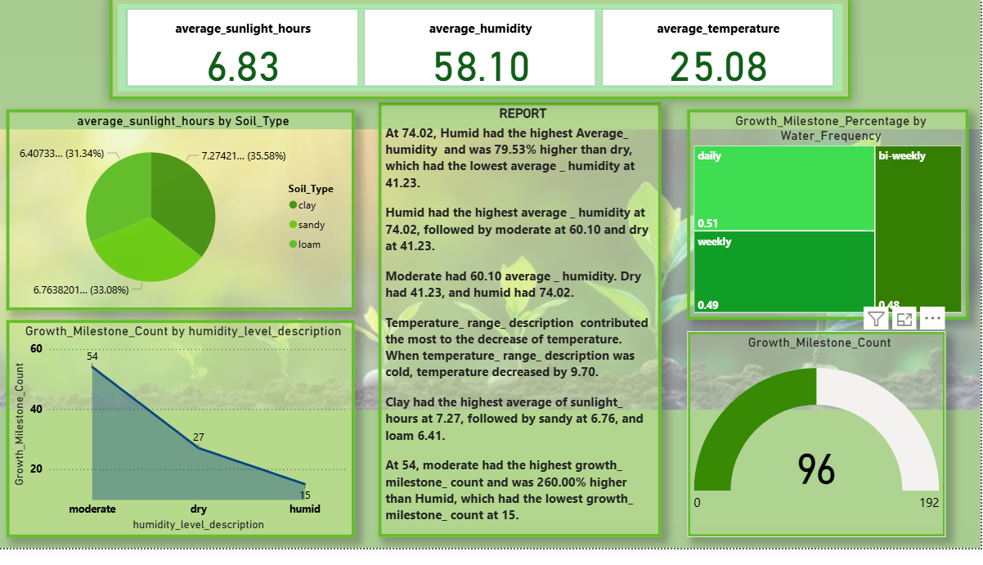

### Visual Insights

#### 1. Average of Sunlight Hours by Soil Type

· Loam soil receives the highest sunlight (7.27 hours avg), followed by sandy (6.76 hours) and clay (6.40 hours).

· **Insight:** Loam’s structure and air permeability allow better light exposure, which supports photosynthesis and growth.

#### 2. Growth Milestone Count by Humidity Level Description

· **Moderate humidity (50–70 %)** produces the highest growth count (54 milestones).

· Dry conditions lead to 27 milestones, while humid conditions drop to 15.

· **Insight:** Excess humidity slows plant metabolism; moderate moisture is optimal for development.

#### 3. Growth Milestone Percentage by Water Frequency

· Daily watering shows a slightly higher success rate (0.51) than weekly (0.49) and bi-weekly (0.48).

· **Insight:** Consistent watering helps stabilize soil moisture, which directly supports steady growth.

#### 4. Sum of Growth Milestones (Gauge Chart)

· The total growth milestone score is **96 out of 192**, representing a mid-level performance (≈ 50 % efficiency).

· **Insight:** This suggests room for optimization through better control of temperature and watering frequency.

#### 5. Text Report and Narrative Visual

· The narrative summarizes data findings automatically:  
 • Humid conditions showed the highest average humidity (74 %).  
 • Temperature drops under “cold” conditions by 9.7 °C.  
 • Clay has the highest average sunlight exposure.  
 • Moderate humidity produced 260 % higher growth than humid conditions.

· **Insight:** Text automation in Power BI adds interpretive depth to the report.

### Overall Observations

· **Ideal growth conditions:** Moderate humidity + daily watering + loam soil + 25 °C temperature.

· **Key growth driver:** Humidity and temperature balance have the strongest impact.

· **Resource efficiency:** Balanced watering and sunlight exposure lead to maximum growth without overuse of inputs.

· **Predictive value:** Findings support data-driven recommendations for greenhouse optimization and smart farming.

### Conclusion

This Power BI report translates raw environmental data into actionable insights. It empowers farm managers to adjust water schedules, monitor humidity ranges, and stabilize temperature for consistent growth outcomes.  
 The combination of interactive visuals, KPIs, and data storytelling makes it a powerful tool for sustainable and data-driven agriculture.